Name: __________________________
Containing Communism
Part 1:
Directions: Use your notes—and you can look back at the PDF from yesterday—to complete the diagram.
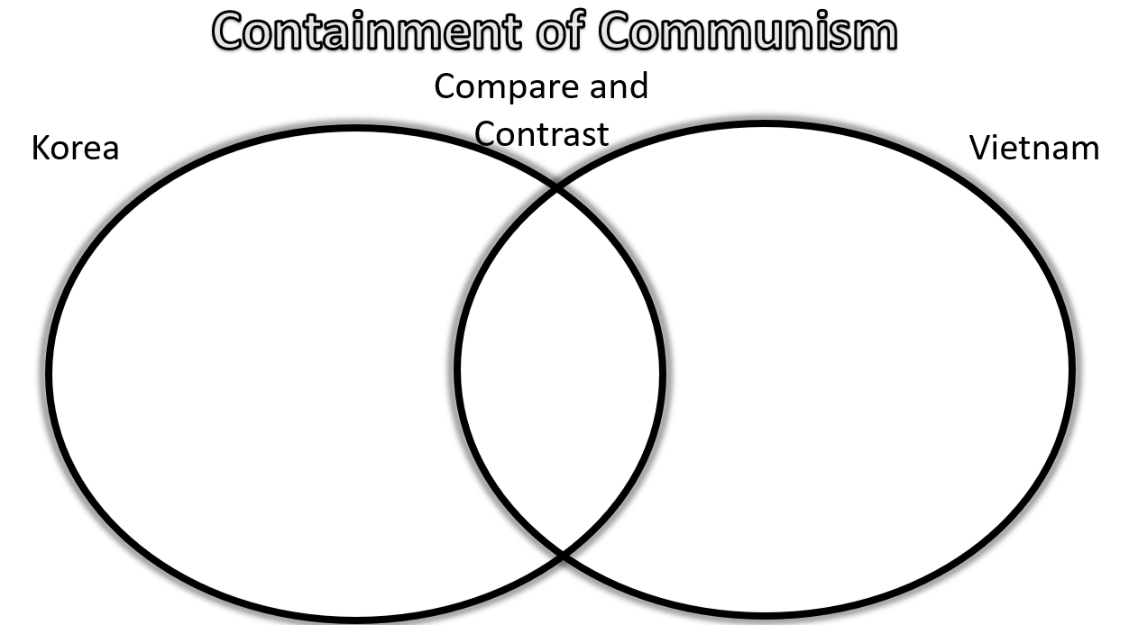
Type here*
Type here*
Type here*

Part 2: After watching the video about the domino effect, go to the Microsoft form an answer the questions.

