Before you make your quiz, you need to pick ONE of the following priority standards to make the 7-10 MULTIPLE CHOICE questions about. These are the ones that we have covered, so you should have notes and knowledge of them:
Standard:
Option 1 | SS7H1  a. Explain how the European partitioning across Africa contributed to conflict, civil war, and artificial political boundaries in Africa today.
Option 2 | SS7CG2 Analyze how government instability in Africa impacts standard of living.  a. Describe the impact of government instability on access to education and the distribution of medicine and food to combat diseases and famine across Africa.
Option 3 | SS7H1 c. Explain the creation and end of apartheid in South Africa and the roles of Nelson Mandela and F.W.de Klerk.
Option 4 | SS7G2 Explain environmental issues across the continent of Africa.  b. Explain the relationship between poor soil and deforestation in Sub-Saharan Africa.  c. Explain the impact of desertification on the environment of Africa.
Option 5 | SS7H2  a. Explain how European partitioning in the Middle East following WWI led to regional conflict.  b. Explain the historical factors contributing to the establishment of the modern State of Israel in 1948; include the Jewish religious connection to the land, antisemitism, the development of Zionism in Europe, and the aftermath of the Holocaust.
Option 6 | SS7CG3 Compare and contrast various forms of government.  - Explain citizen participation in autocratic and democratic governments  b. Describe the two predominant forms of democratic governments: parliamentary and presidential.

I would suggest you try making a few questions before you choose your standard option and move on to the quizizz step.

Quizizz instructions sheet:

- First you must create a quizizz account here: https://quizizz.com/signup?q=%2F&source=home (if your parents will not allow you to create an account, that is okay too. You can just email me your questions and answer options. If I have time I will make a few and post them.)
- Once you have made your account you must create the quiz—click on Create a new quiz.
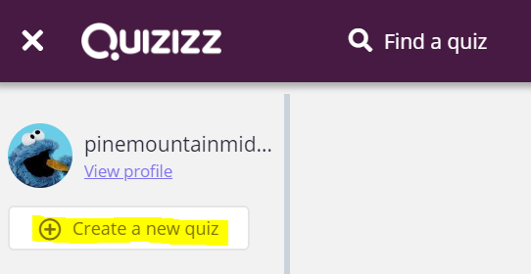

- You need to create a title (I suggest one based on the priority standard that you chose). And then choose the classes it relates to (like US history, World History, or geography).
- Then click the “Create a new question” button at the top left.
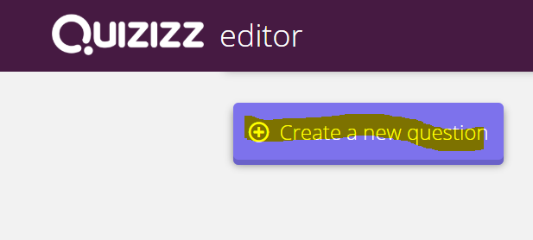
- From here you will enter the questions and answers in the places it asks you to. Please remember you only want one correct answer. Click the check mark next to the answer choice that is the correct answer.
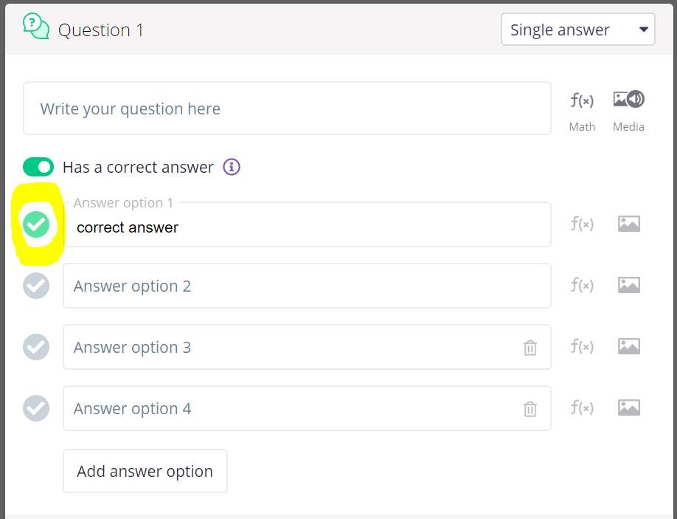
- Repeat step 5 until you have your 7-10 questions.
- Now you are ready to click the “Finish Quiz” button in the top right-hand corner of your screen
- Click the grades that it applies to—I’d suggest 6-8th grades.
- Then it gives you the option to share it using someone’s email. Use mine: oscar.caldwell@cobbk12.org
- Now, wait on me to post them so you can quiz one another on the priority standards

