Name: _____________________________
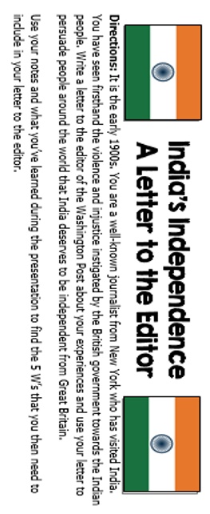

Who? (Who are the groups involved?)
What? (What is happening?)
When? (What was the time period it all happened?)
Where? (Where was this happening?)
Why? (Why was this happening?)

Now, write your letter on the back!

Letter to the editor:

Sincerely,

(your name)

