Name:
SE Asia Government and Economics Study Guide 2019
SS7CG4 Compare and contrast various forms of government.  a. Explain the role of citizen participation in autocratic and democratic governments [i.e. explain the role of citizens in choosing the leaders of China (communist state), Japan (parliamentary democracies), North Korea (autocracy), South Korea (presidential democracy), and India (parliamentary democracy)]. | 1. Which Asian country is the world’s largest democracy?  2. In North Korea Everyone 17 years or older must vote for a legislative candidate listed by the Communists party. Voting is not anonymous and is monitored. The legislature is governed by the Supreme leader and a small group of advisors that he chooses. Since the Supreme leader has all of the power and the citizens have no voice in their government, North Korea is best described as a(n) ______________________.  3. How is the government of South Korea different than the government of India?  4. In China, the Chinese Communist Party chooses candidates for local elections, and the Party chooses the people who can vote. All citizens who are chosen to participate are members of the Chinese Communist Party. What type of government does China have? ___________________________  5. In Japan, the leader has recently faced charges of corruption. If he is found guilty, the Diet could remove him and vote on another leader. Which type of government fits this description?
b. Describe the two predominant forms of democratic governments: parliamentary and presidential. | 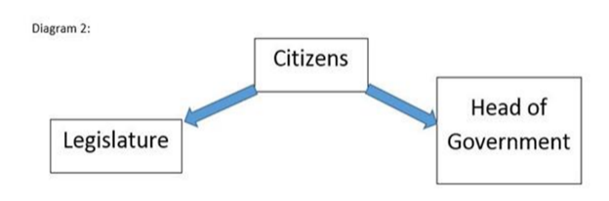  6. South Korea has the type of government that is being illustrated below. What type of government does South Korea have?  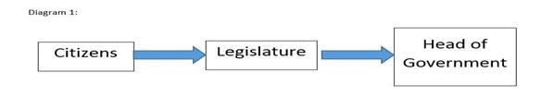  7. India and Japan have the type of government that is being illustrated above. What type of government do they have?  8. Countries with this type of government have a head of state and a head of government. The head of state position is mostly ceremonial and the head of the government position runs the government. The leaders of the legislative branch choose the head of government. What type of government is this?  9. In this type of government the head of state and the head of government is the same person. The leader is directly voted into office by citizens. What type of government is this?  10. Citizens of South Korea gain suffrage at age 19. The citizens directly elect both the legislature and President, just as we do here in the United States. How would South Korea’s government best be described?
Quizizz Code:

